Notes to Owner

1. Overview

Dear restaurant owner, this Food Order System has mainly x advantages.

1. Comprehensive and intelligent functions
2. Beautiful and humanized UI
3. Friendly to managers

Here are the details about this system.

1. Functions provided
2. **Beautiful and humanized UI.** This would give your customers a good first impression. (please check User Guide for details)
3. 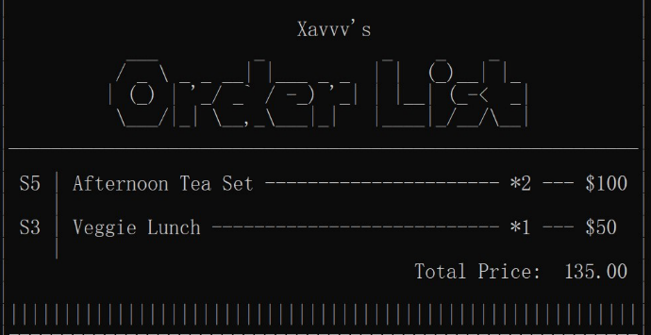**User order list.** The system will record all the items that users has ordered. The user order list will be shown on the screen every time the user finish ordering an item. This could help users to track their order process.
4. **Automatic packaging.** The system will check if any items in the user’s order list could be packaged into set meals, and package them automatically. This function will work every time the user order an item, in order to keep the user’s order list updated. (e.g. A1 + C5 = S3)

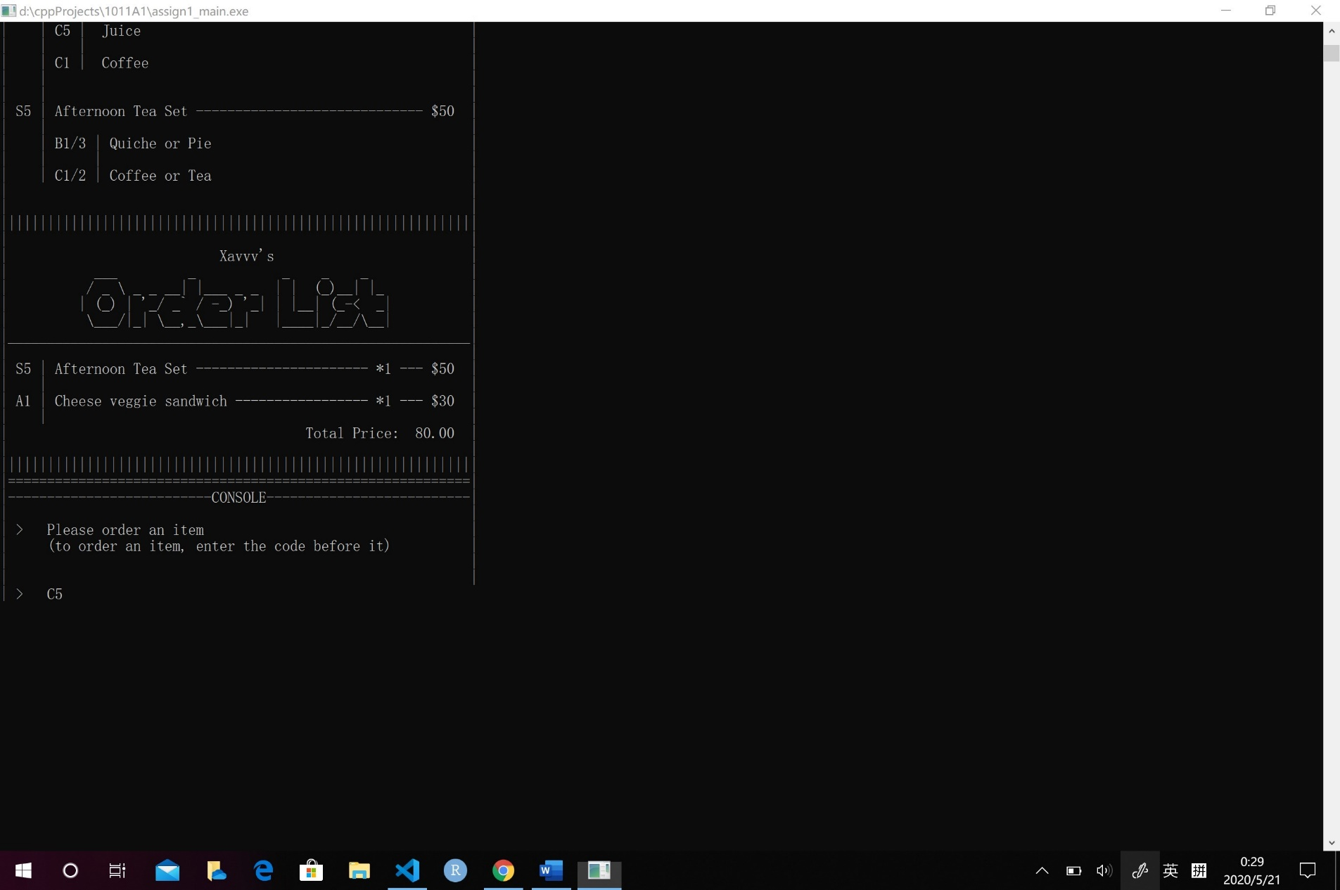

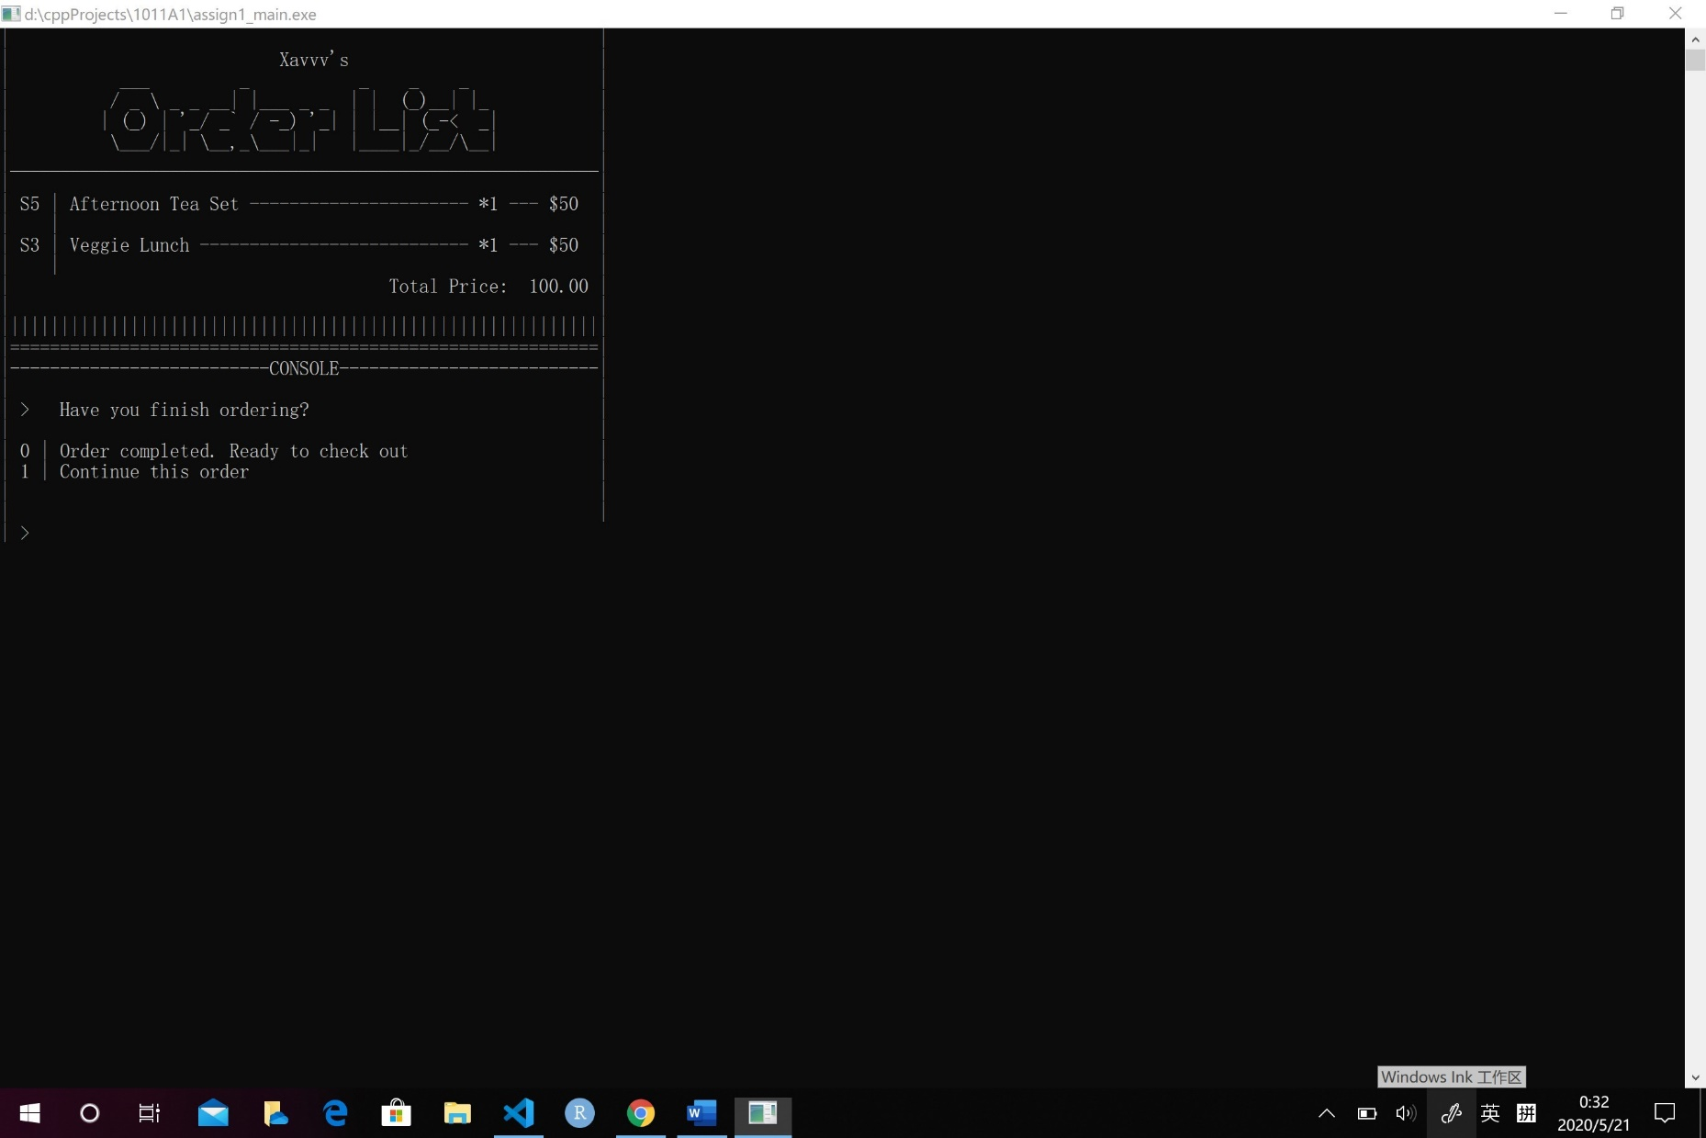

1. **Automatic pricing.** The system can also calculate the price of all the items in the user’s order list. 10% discount will be given if the total price is over $100.
2. 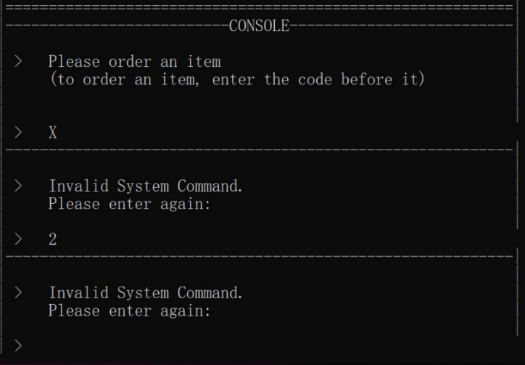**Grammer check function.** When user enter an invalid command, the system will show an error prompt. Then the system will ask the user to enter again until and valid command is entered.
3. Warm reminders
4. User can only order one food item at one time.
5. The user’s Order Identification String will be printed on the user’s order list. So it would be easy for the Café managers to find the order lists corresponding to the customers.
6. Every time the user enter a valid command, the screen will be refreshed and print out the updated messages.
7. 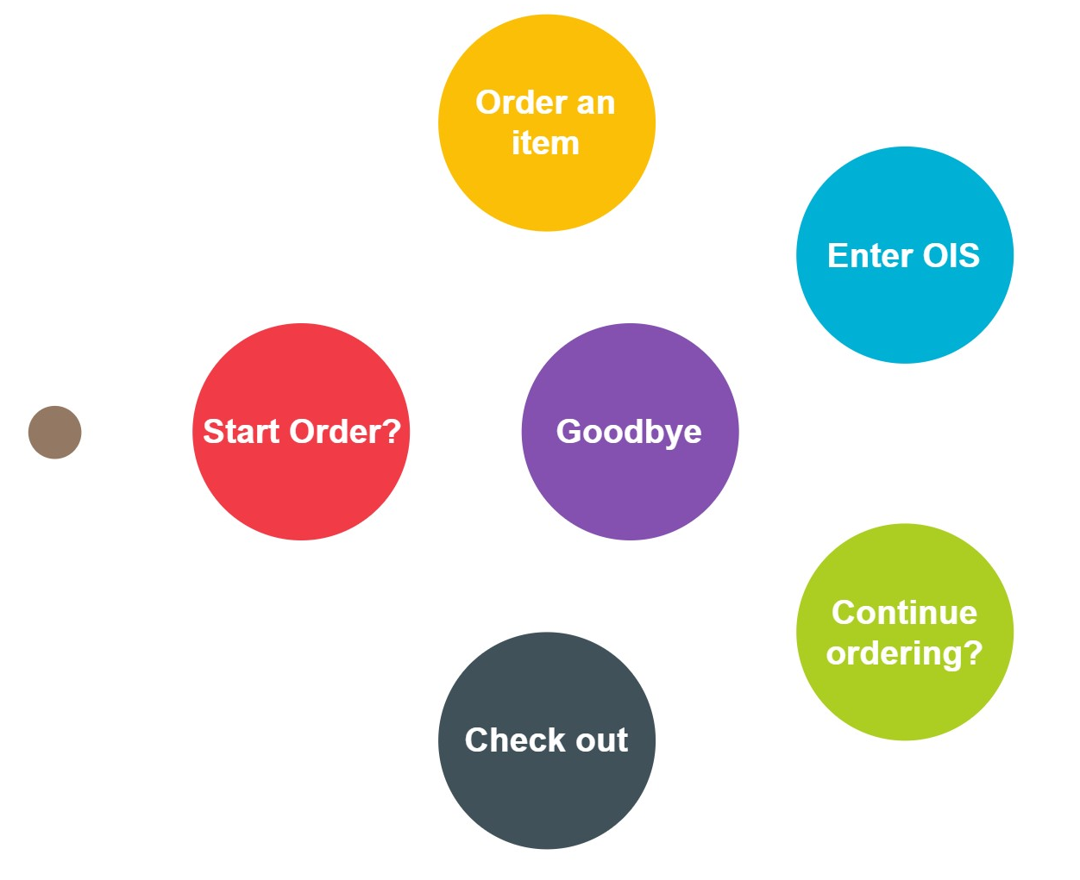Process of the system:

**Y**

**N**

**Y**

**N**

**start**